Table of Contents
Low-Cost Profiler Manual

Table of Contents -------------------------------------------------------- 1

Parts List ------------------------------------------------------------------ 2

Tool List ------------------------------------------------------------------- 3

Inner Assembly ---------------------------------------------------------- 4

Outer Assembly ---------------------------------------------------------- 5

Sensor Cap Assembly --------------------------------------------------- 6

Flashing the Control Board -------------------------------------------- 7

Parts List

Parts List

Inner Assembly Parts:

Part Number | Part Name | Description | Stock size | Vendor+link | Quantity | image | Git number
1 | FA-BH50-XXX-12-12 | Firgelli Bullet Series 50 Cal. Linear Actuator, 12" stroke | FA-BH50-XXXX-12-12 | Firgelli Automation  part site | 1 | 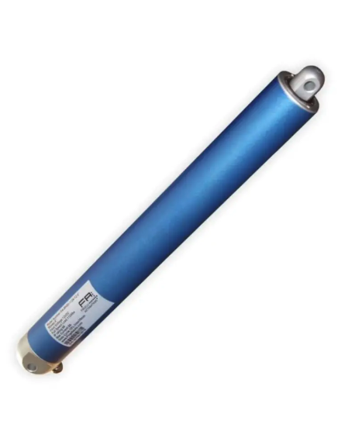 | 4
2 | Actuator Mount | Two sided threaded mount |  | part file | 1 | 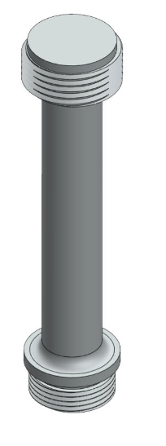 | 36
3 | N4274_250_02250 | 2.25" ID Parker PolyPak SPP Hydraulic Seal | N4274-250-02250 | Parker  part link | 1 | 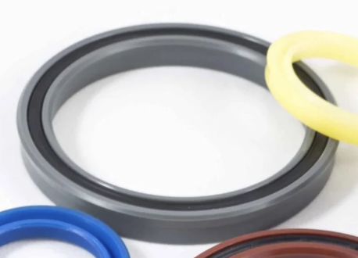 | 46
4 | 000524 | Low Cost Profiler Piston #1 | PVC Type I Rod 1 | In house  part file | 1 | 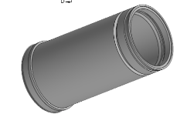 | 3
5 | N4274_250_04000 | 4" ID Parker PolyPak SPP Hydraulic Seal | N4274-250-04000 | Parker  part link | 1 |  | 45
6 | 92981A309_ALLOY STEEL SHOULDER SCREW | M8 x 1.25mm, 10mm Dia x 70mm L, Shoulder Screw | 92981A309 | McMasterCarr  part link | 1 | 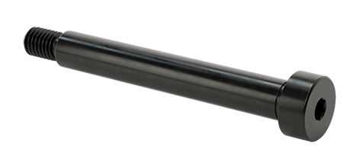 | 25
7 | 000525 | Low Cost Profiler Piston #2 |  | part file | 1 | 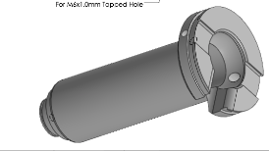 | 5
8 | 0307-PDT-H-093-0250 | 7.31" Long 0307-PDT-H-093-0250 | 7.31" Long | Parker  part link |  | 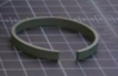 | 42
9 | 0307-PDT-H-093-0250 | 11.44" Long 0307-PDT-H-093-0250 | 11.44" Long | Parker  part link |  |  | 44
10 | 500142 | Low Cost Profiler Gas Spring Ring |  | Part file | 2 | 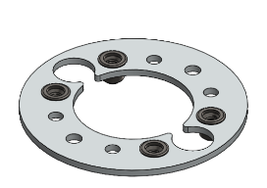 | 13
11 | 98455A161 | 100mm Steel Internal Retaining Ring | MMC# 98455A161 | McMasterCarr  part link | 1 | 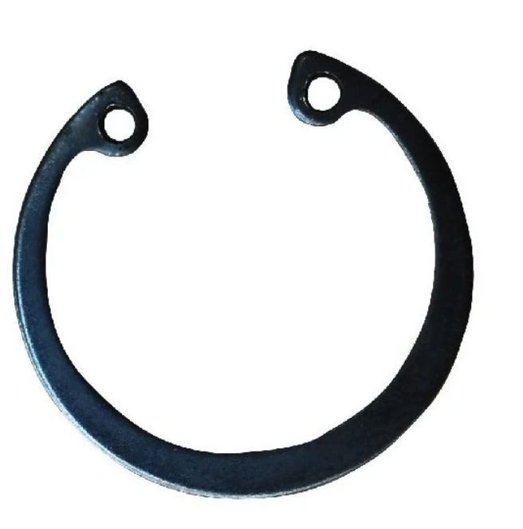 | 7
12 | 89U140341TT0667  Gas Springs | IGS 8/18 x 140mm Gas Spring |  | Industrial Gas Spring  part link | 2 | 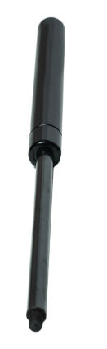 | 6
13 | 90576A115 | M6 x 1mm, Medium-Strength Steel Nylon-Insert Locknut | 90576A115 | McMaster Carr  part link | 2 | 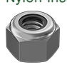 | 17
14 | 91290A155 | M6 x 1mm , 200mm L, Alloy Steel Socket Head Screw | MMC# 91290A155 | McMaster Carr  part link | 1 | 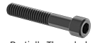 | 15
15 | 91166A250 | M6 , 6.4 mm ID, 12 mm OD, Zinc-Plated Steel Washer | MMC# 91166A250 | McMaster Carr  part link | 4 | 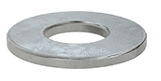 | 16
16 | Note: add something about the battery holders and inserting the batteries.
17 | Low Cost Profiler Battery Power Management Board | Low Cost Profiler Battery Power Management Board |  |  | 1 |  | 53
18 | Low Cost Profiler Battery Rod  000542 | M6 x 1.0mm Nylon 6/6 Threaded Rod  6.25" Long | MMC# 98882A249 | McMaster Carr  part link | 4 | 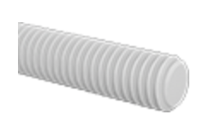 | 48
19 | 93369A141 | M6 x 1mm, Nylon Hex Nut | MMC# 93800A600 | McMaster Carr  part link | 4 | 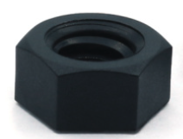 | 23
20 | 95610A370_NYLON PLASTIC WASHER_ | M6, 6.4mm ID, x 12mm OD, Nylon Plastic Washer | MMC# 95610A570 | McMaster Carr  part link | 4 | 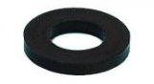 | 27

Endcap Assembly:

Item Number | Part Number | Description | Description | Vendor Link | Image Link
21 | 98455A224 | 19mm ID Internal Retaining Ring, Black-Phosphate Spring Steel | MMC# 98455A224 | McMaster Carr  part link | 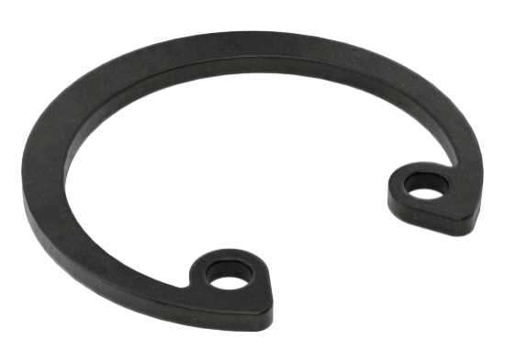
22 | 97414A705 | 1" OD Low-Clearance External Retaining Ring, Spring Steel | MMC# 97414A705 | McMaster Carr  part file | 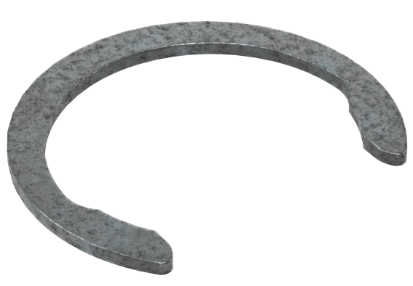
23 | Keller 9LX | Keller 9LX 30 Bar OEM Pressure Sensor | 9LX-30 Bar | Keller America  part link | 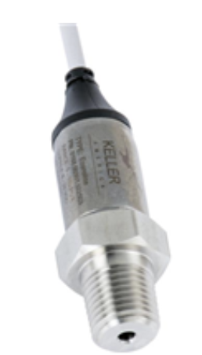
24 | 000547 | Low Cost Profiler Antenna Housing | Type 1 | In-house  part file | 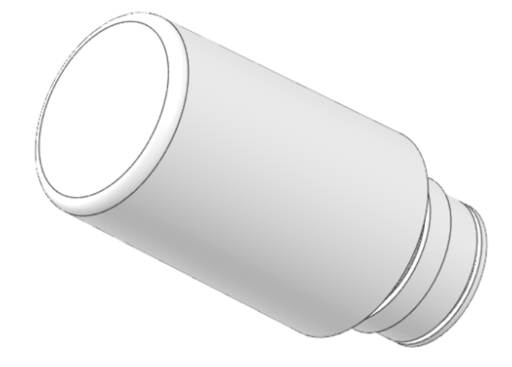
25 | 92290A139 | M4 x 0.7mm Thread, 6mm L, 316 SS Socket Head Screw | MMC# 92290A139 | McMaster Carr | 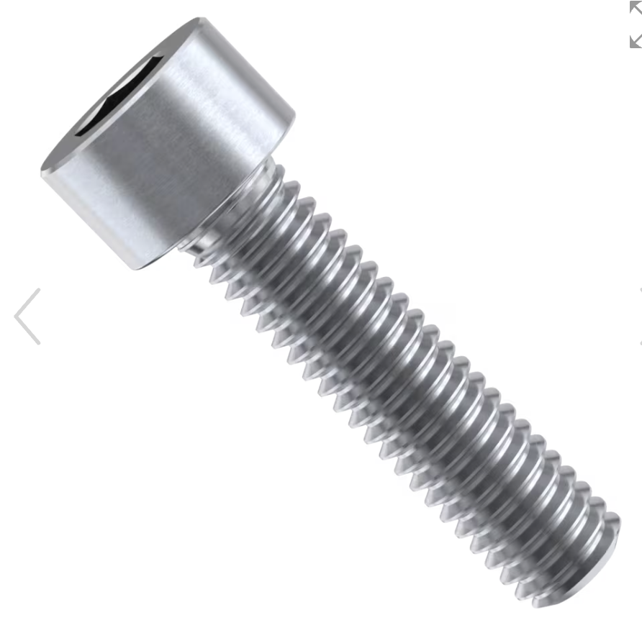
26 | HC600E | Tallysman OEM Iridium Helix Antenna | HC600E | Tallysman Wireless
28 | 98555A230 | 1-3/8" OD Side-Mount External Retaining Ring, Steel | MMC# 98555A230 | McMaster Carr  part link | 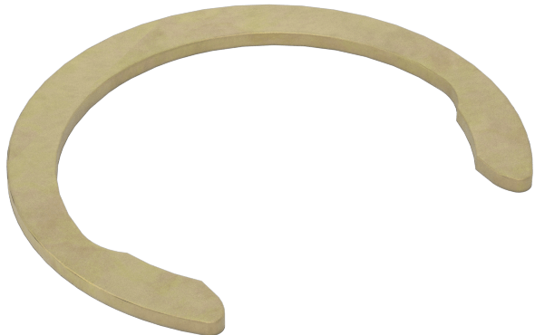
33 | 92131A630 | 28mm ID Single-Turn Spiral Internal Retaining Ring, 1090 Spring Steel | MMC# 92131A630 | McMaster Carr  part link | 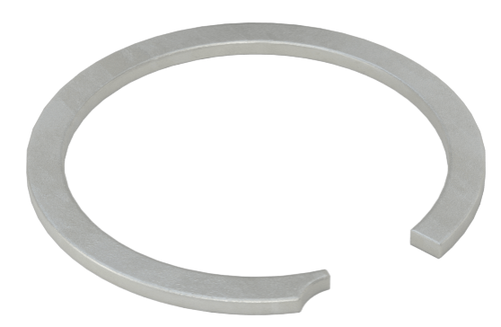
36 | Low Cost Profiler Main Control Board | Low Cost Profiler Main Control Board |  | In-House
37 | 9452K84 | 2-120 Buna N O-Ring 4 | 2-120, MMC# 9452K84 | McMaster Carr  part link | 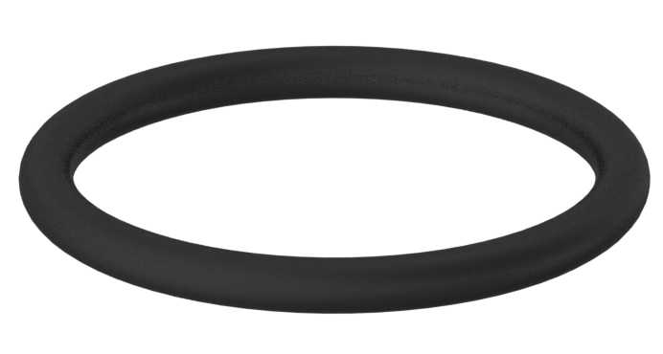
38 | 9452K89 | 2-125 Buna N O-Ring 1 | 2-125, MMC# 9452K89 | McMaster Carr  part link | 
39 | 9452K194 | 2-244 Buna N O-Ring 1 | 2-244, MMC# 9452K194 | McMaster Carr  part link | 
40 | 000531 | RBR Coda Sensor Port | Type 1 | part file | 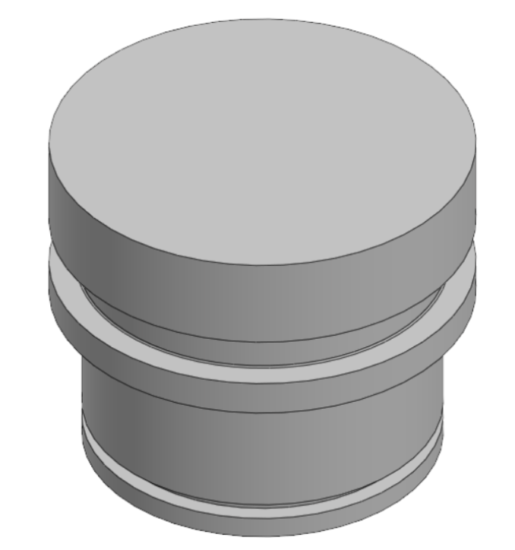
41 | 000531 | 9LX Pressure Port | Type 1 | part file | 
42 | 000531 | 7/16-20 Threaded Port 1 | Type 1 | part file | 
43 | 000531 | Turner Cyclops CHLA Sensor Port | Type 1 | part file | 
44 | 2110-000-C-NH | Turner Cyclops 7F CHLA, No Housing OEM 1 | Cyclops 7F- No Housing Version | Turner Designs Inc.  part link
45 | 500126 | LFS1107 Conductivity Sensor 1

Outer Assembly Parts:

Item Number | Part Name | Step used | Description | Vendor Link | Image Link
46 | 000521 | 2, 5, 7, 10, 11, 12 | LCP Housing | Amalga Composites
47 | 000522 | 9, 11, 12, 13 20 | LCP Instrument endcap | 522
48 | 91650A490 | 16 21 | 1-3/8" OD, Heavy Duty Spiral External Retaining Ring, 18 8 Stainless Steel | McMaster Carr
49 | 000539 | 14, 15, 16 29 | LCP Brush Drag Plate Retainer | 0539
50 | 000546 | 15 31 | Low Cost Profiler Drag Brush | Memtech Inc.
51 | 92290A139 | 13 36 | M4 x 0.7mm Thread, 6mm L, Socket Head Screw | McMaster Carr  https://www.mcmaster.com/91290A139/
52 | 000532 | 8, 9, 41 | Low Cost Profiler Actuator Mount | 532
53 | 94241A520 | 13 | M4 Split Lock Washer, 4.4mm ID x 7mm OD, 316 Stainless Steel | McMaster Carr

Tool List and Installation Tools

Tool List + Installation Tools
Inner Assembly and Installation Tools
Tool/Adhesive number | Step Used | Tool description | Vendor | Image
1 | Step 4: Install seal #45 onto piston #3 | Piston1 Seal Installation Tool A Assembly, 500195 | In-house build | 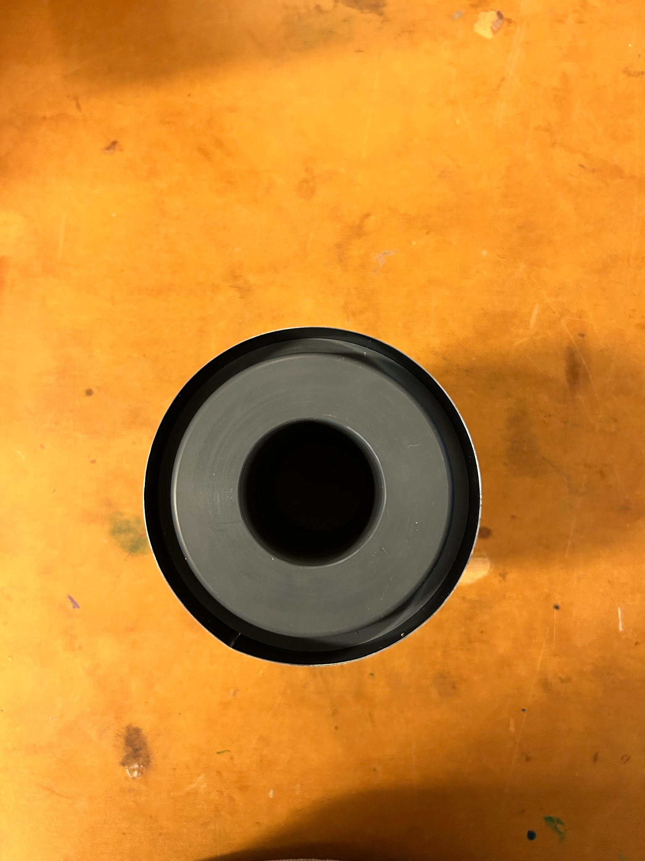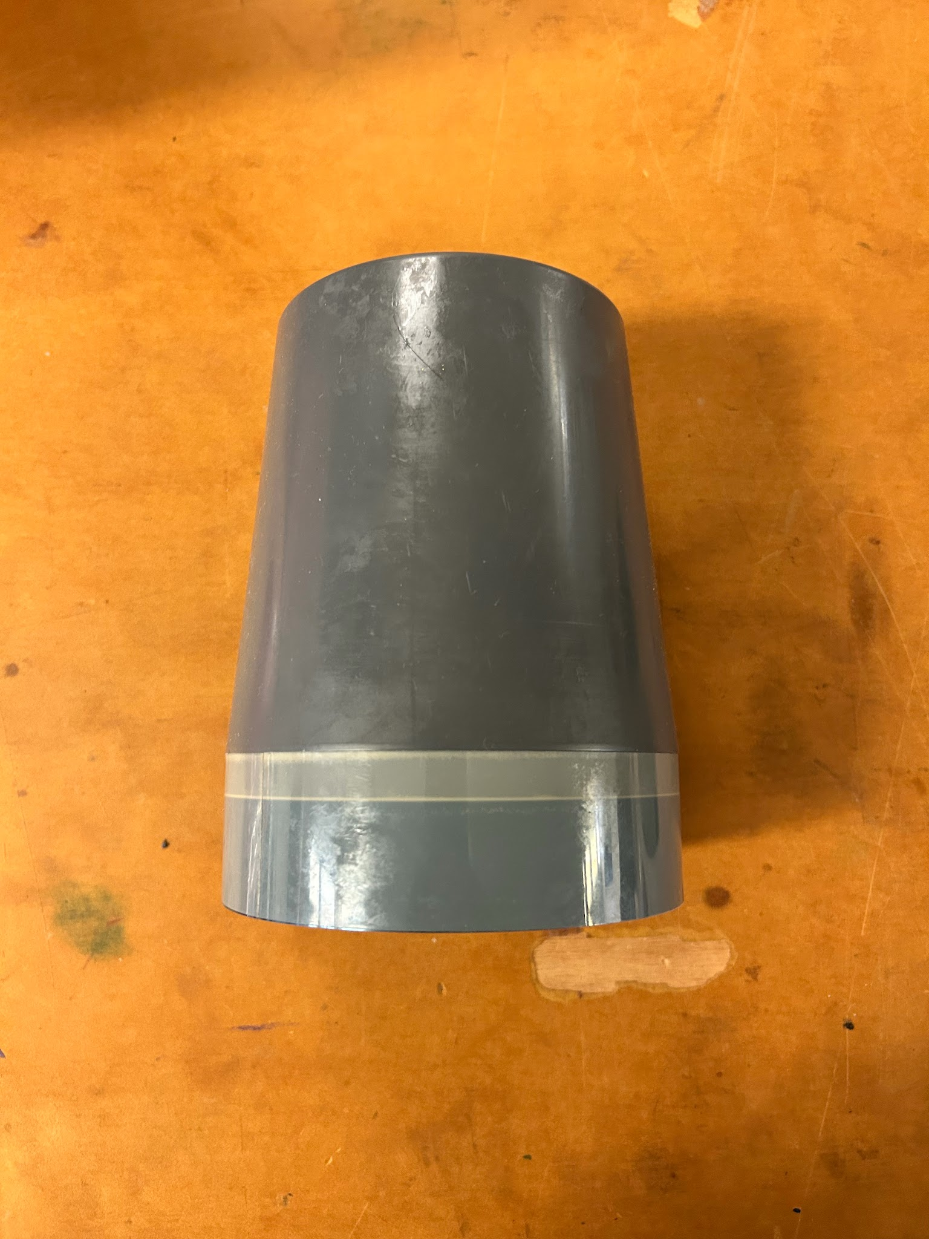
2 | Steps 8 & 11: Install onto #5 before inserting into #3, then remove after | Piston2 Seal Installation Tool, 000574 |  | 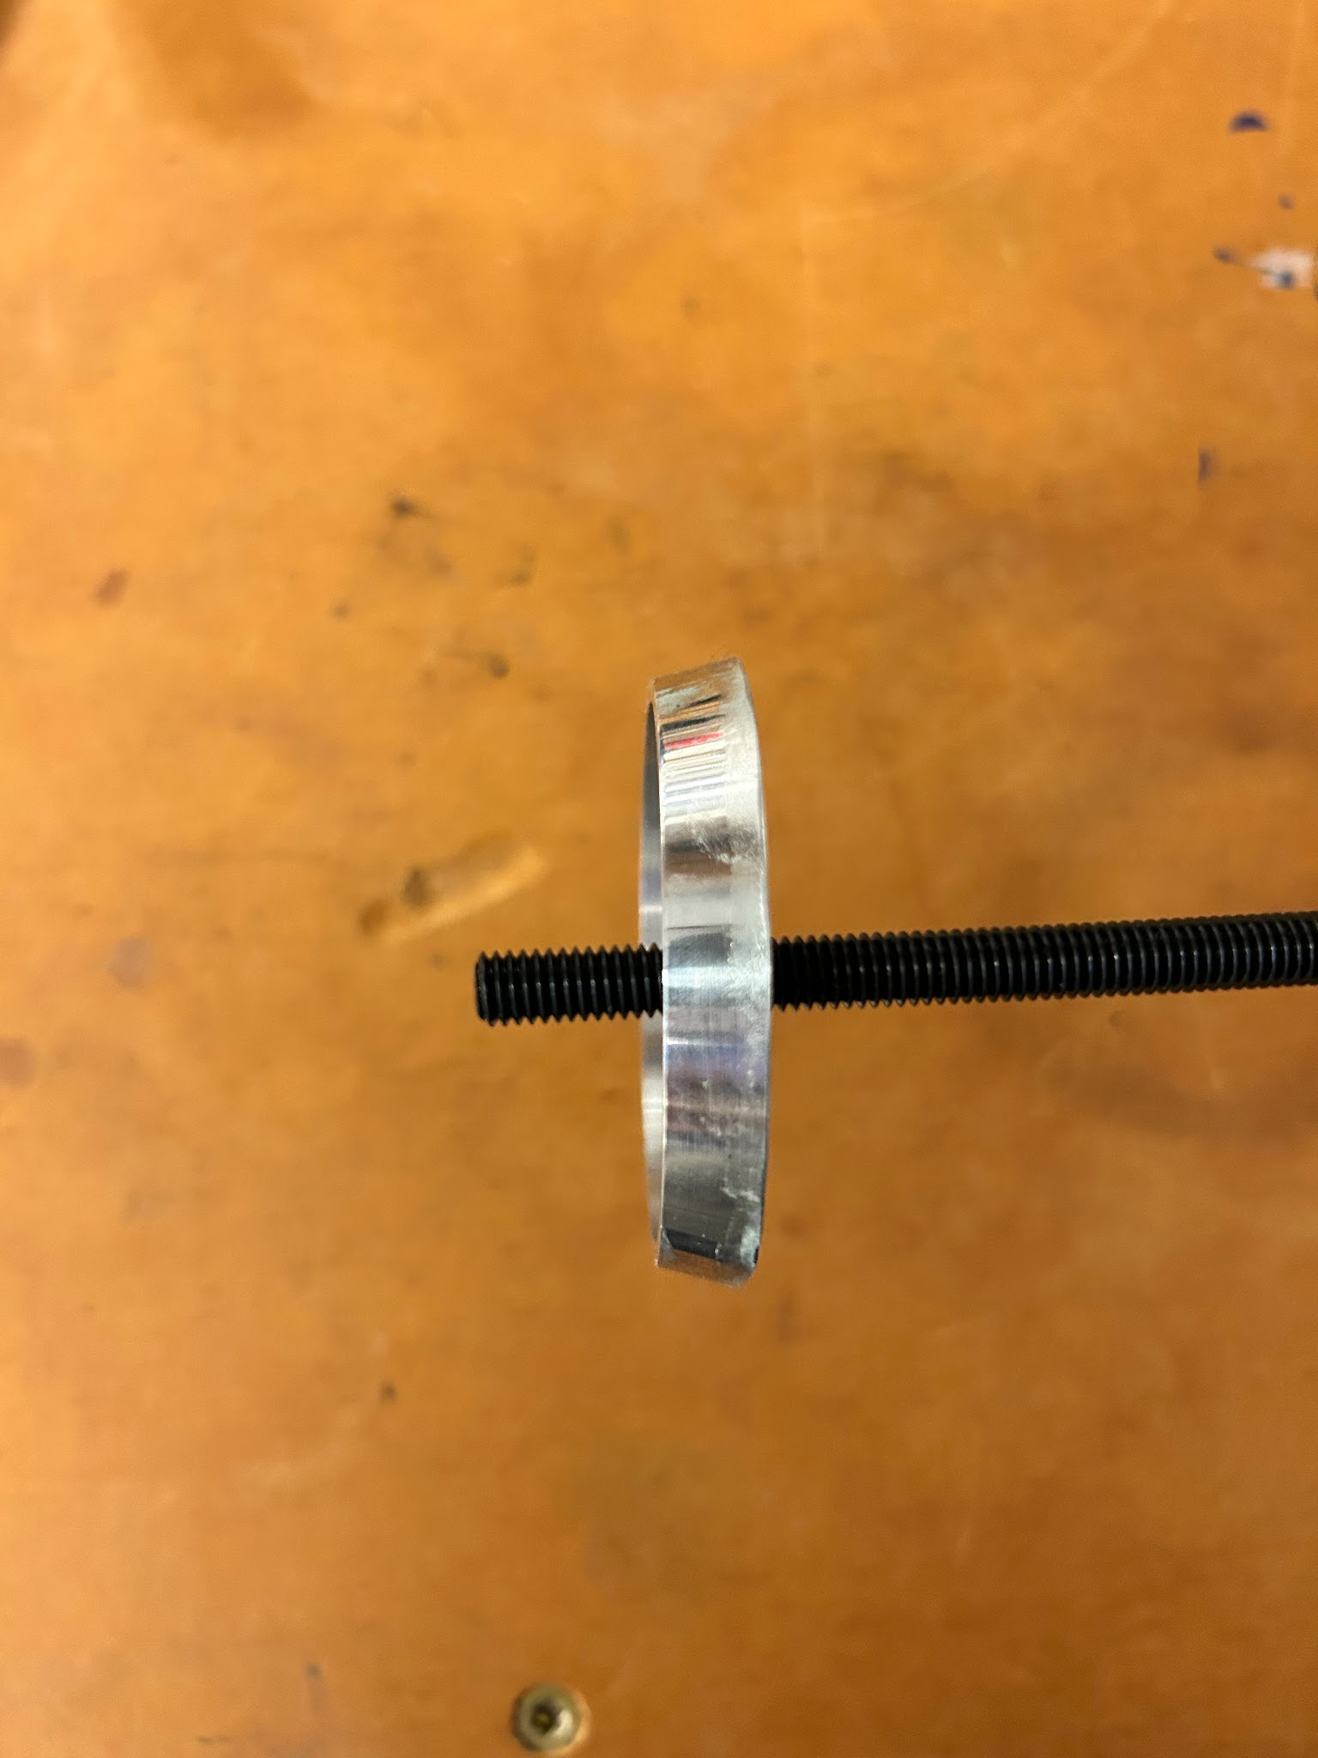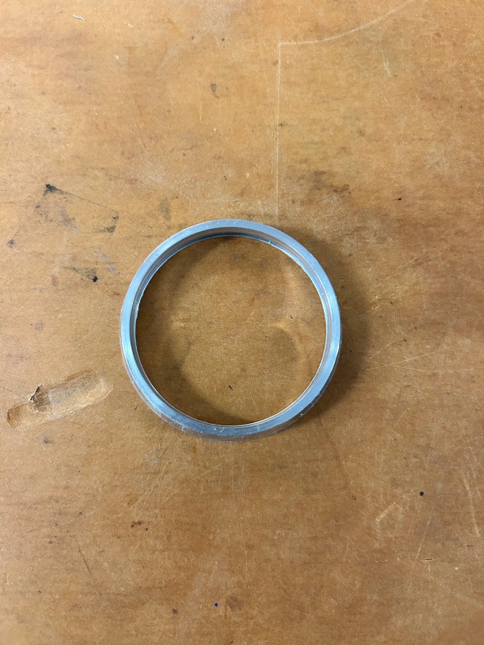
3 | Step 14: Installing #7 retaining ring to secure #13 to #3 | Large Internal Retaining Ring pliers | https://www.mcmaster.com/5391A37/ | 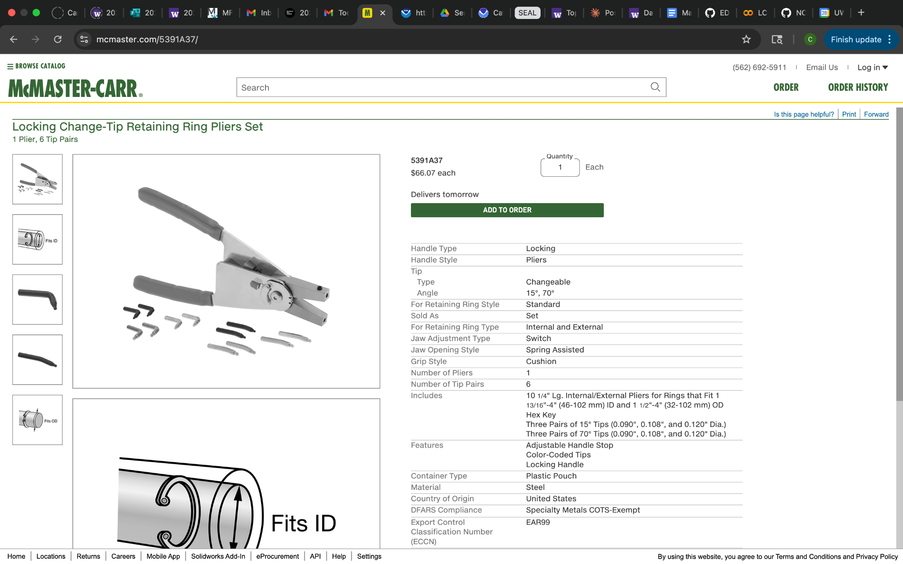
4 | Steps 17: Bolting upper #13 assemblies with #15 4x | 5mm hex drive screwdriver | 5mm screwdriver | 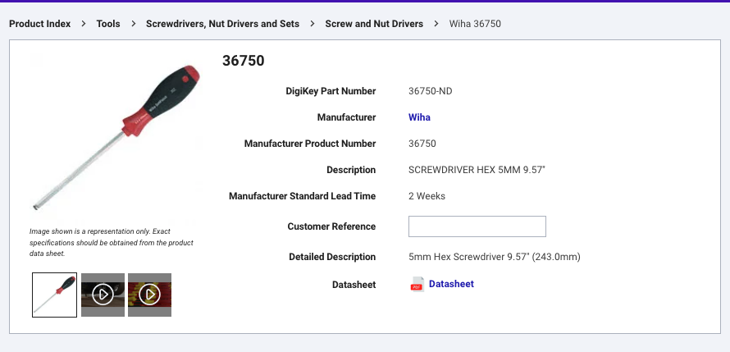

Adhesive and Consumables
Tool# | Step Used | Adhesive/Consumable | Vendor | Image
T5 | Steps 2, 5, 17, 20–21: Coating #36 before screwing into #4; cleaning and coating #25 threads; coating #15 threads before installing through upper #13 | Loctite 425 Threadlocker | Loctite threadlocker | 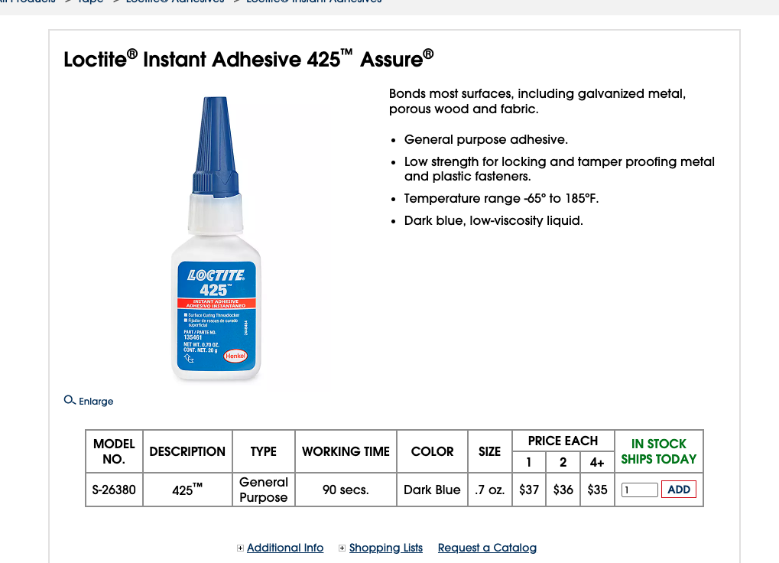
T6 | Steps 3, 4, 7: Installing #46 into #3; installing #45 onto #3; greasing bore of #3 and OD of #5 before inserting piston | Aquashield Waterproof Grease | Aqua Shield | 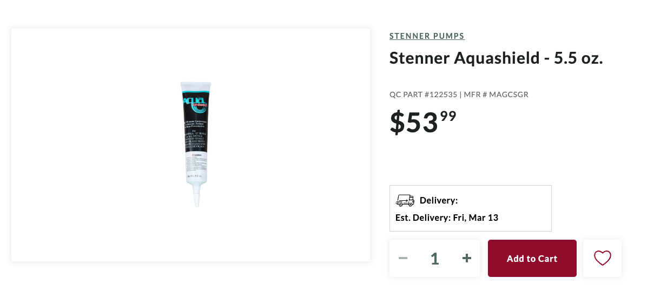
 | Sensor Step 4: Lightly greasing O-rings and IDs of #2 ports | Dow Molykote 111 O-Ring Silicone Lubricant | Molykote Link | 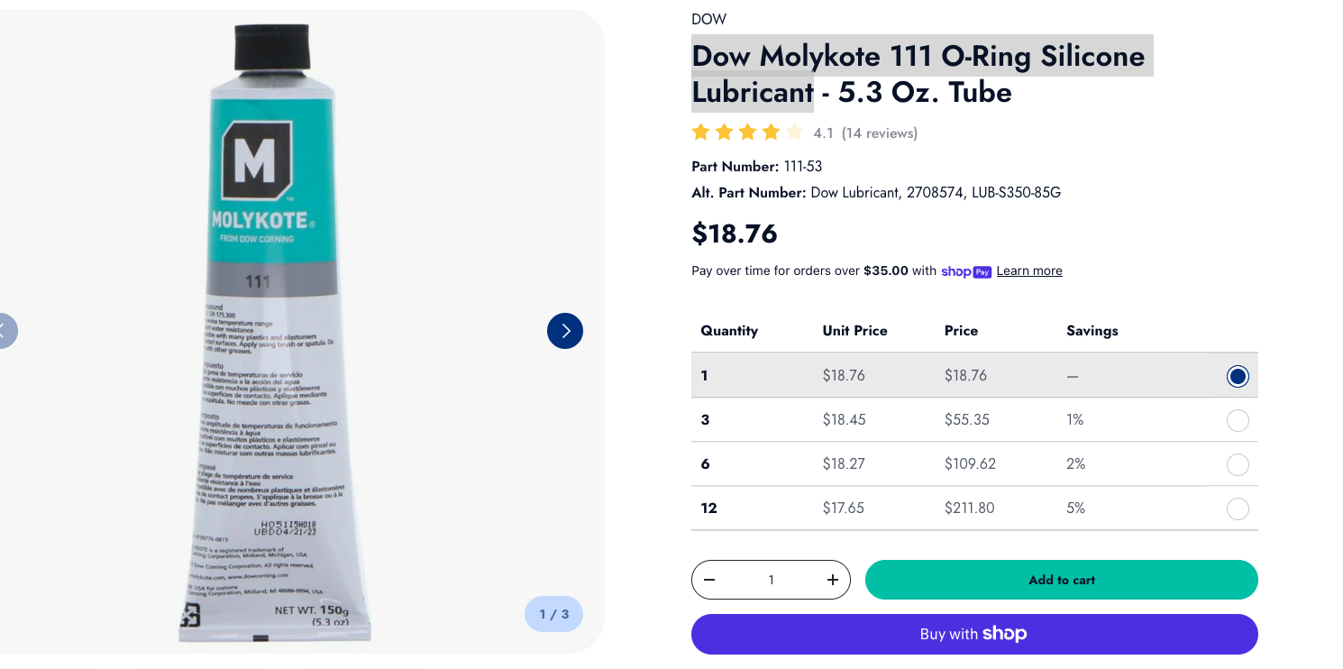
 | Step 3: Covering top of pressure port hole #8 while filling sensor cup with gear oil | Tape (for covering pressure port during filling) | Electrical Tape | 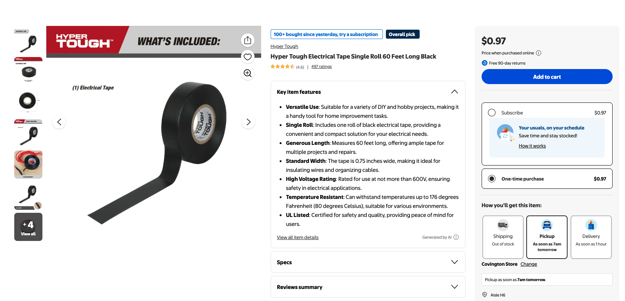
 | Steps 13 & 15: Securing actuator cable at #13 plate exit points | Zip Ties  (MMC# 7130K13) | Zip Ties | 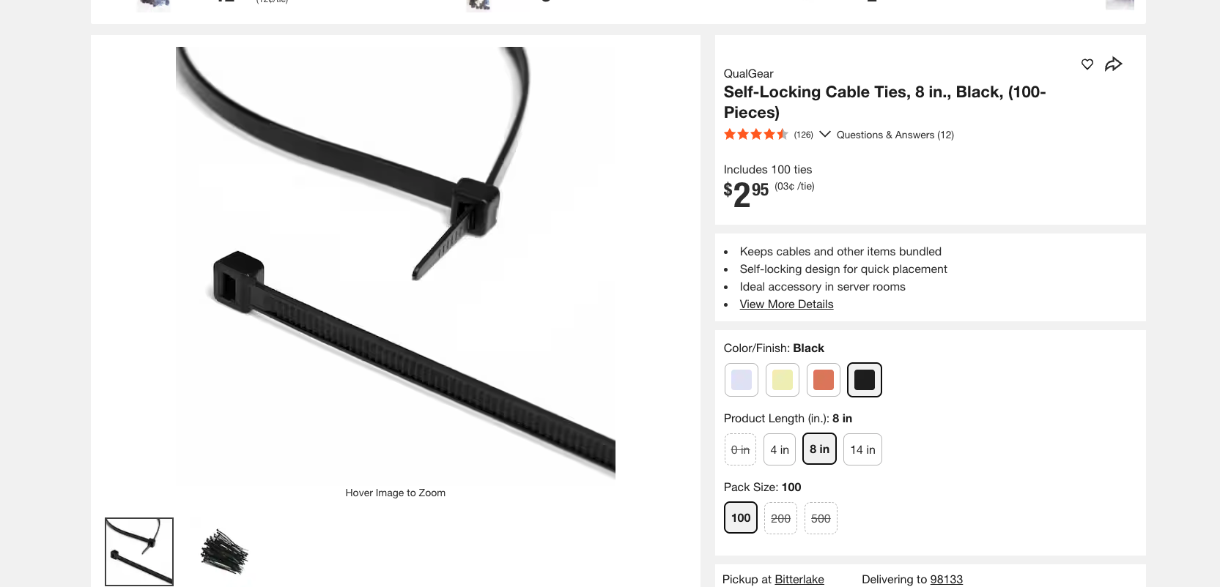

Outer Assembly Installation tool + Adhesives and Consumables

Step Used | Description | Vendor Link | Image
3, 4, 8, 13 | Loctite 425 Threadlocker | Loctite threadlocker | 
5, 11 | Dow Molykote 111 O-Ring Silicone Lubricant | Molykote Link | 
2, 6 | Aqua Shield Waterproof Grease | Aqua Shield | 
7, 13 | 3mm Hex Drive Screwdriver | 3 mm Hex | 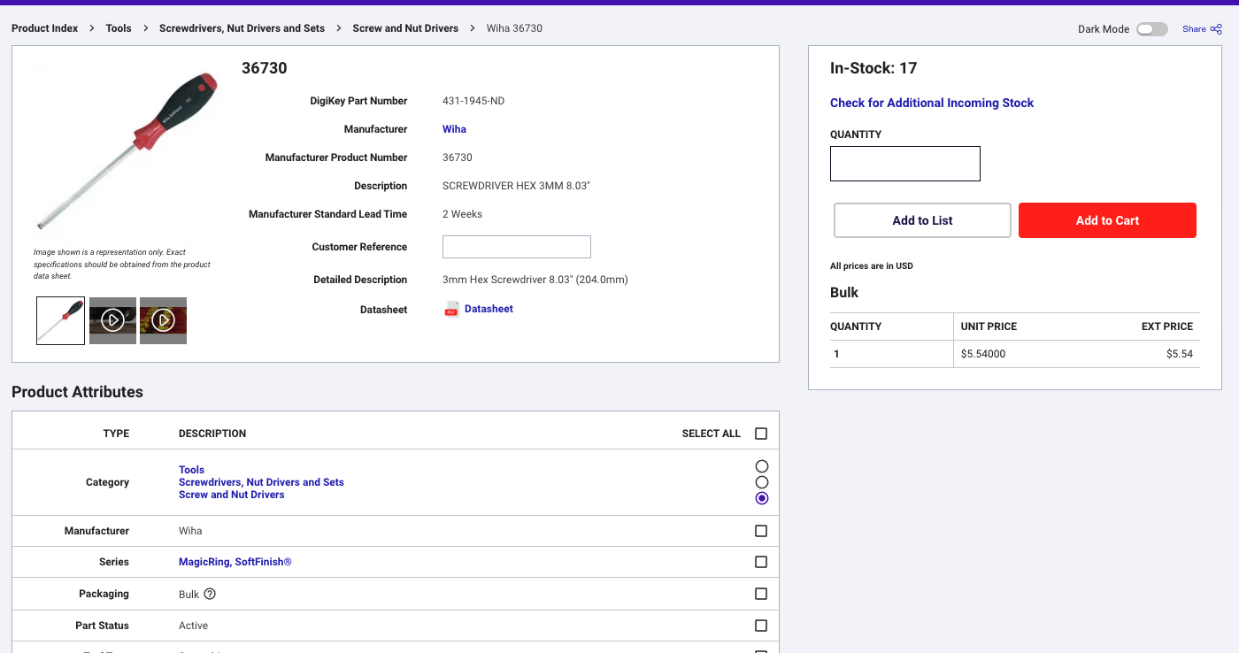

Endcap Assembly

Step Used | Description | Vendor Link | Image Link
1, 4, Pushing in retaining rings, | Flathead screwdriver(3-6/16”)  Any tool that can help push retaining rings in. | Flathead Screwdriver | 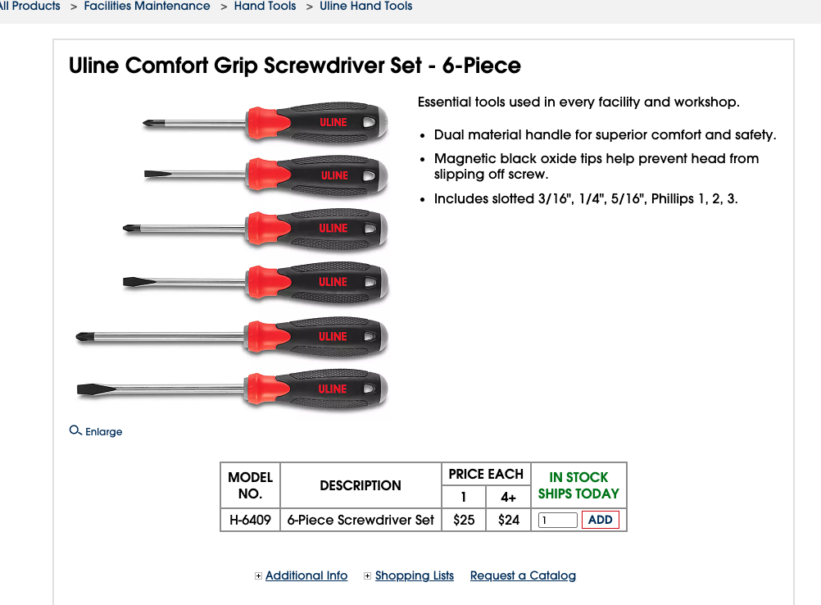
4 | Dow Molykote 111 O-Ring Silicone Lubricant | Molykote Link | 
5 | Loctite 425 Threadlocker | Loctite threadlocker | 

Inner Assembly

Inner Assembly

- Unscrew the rod end of the actuator if still attached shown in Figure 1. Make sure to not unscrew the actuator rod.
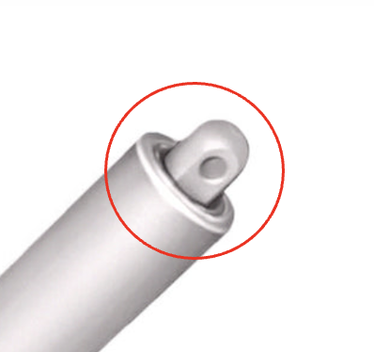
Figure 1. The rod end is circled in red.

- Lightly coat LCP Actuator mount (#36) with vibratight threadlocker (T5), wait at least 15 mins
- Screw into the Actuator (#4). Double check the #4’s rod is fully screwed into the actuator.
- Lightly grease Hydraulic seal (#45) and install onto LCP Piston #1 (part #3)
  - #45 is the bigger one
  - The O-ring goes towards pressure
    - Pressure is coming from the outside
    - Rounded end is the pressure end
- Lightly grease Hydraulic seal (#46 ) and insert into LCP piston #1
  - #46 goes in the top groove
  - O-ring up

- Clean #25 threads with IPA and grease with Vibratight threadlocker, attach LCP Actuator to LCP Piston #2 with #25.
- Install Wear Ring #42 into LCP Piston #1 (part #3)
- Using Aquashield, generously grease the inner bore of LCP Piston #1 (part #3) and the outside diameter of LCP Piston #2 (part #5)
- Install Piston 2 installation tool, 000574, onto LCP Piston #2 (part #5)
- Install wear ring (#44) onto LCP Piston #2 (part #5) so that the ends of #44 are aligned with LCP Piston #2s wire clearance.
- Insert LCP Piston #2 (part #5) into LCP Piston #1 (part #3)
  - Can use a pair of needle nose pliers to gently pull on the end of #44 during installation
  - After installation move actuator cable to the inside of the wear ring
- Remove Piston installation tool 00574
- Pass the #4 actuator’s cable through the lower LCP Gas Spring Ring (#13) using one of the gas spring mounting holes located 90 degrees from the ear cutouts
  - Add a photo of the ear cut outs
- Make sure LCP Piston #2 - (part #5) is fully extended in LCP Piston #1 - (part #3),

- Fully seat #13 in LCP Piston #1(a rim will prevent it from going further), pull the cable tight and mark where it exits the top of #13.
- Remove #13, then measure 1" from mark on cable towards the end of where the wire ends
- Install a zip tie around the cable (MMC#7130K13), tight enough that it does not move on the cable.
- Retract piston #5 and install lower #13 as shown into #3
  - Mark location of # 13 gas spring ear cutouts on #3’s ID so they align with the 2 counterbored slots in the top of #5
  - Fully extend piston #5
  - Secure #13 to #3 with 100mm Steel Internal Retaining Ring (#7) so the free ends are 180 degrees from the actuator cable
- Add a second ziptie around the cable ~ 0.25" above where cable exits #13’s plate.
- 2X: Bolt Gas Spring #6 to Upper #13 as shown with Nylon-Insert Locknut (#17)

- Apply Vibratight threadlocker to the threads of four #15 fasteners. Allow the threadlocker to cure for a minimum of 15 minutes.
- Install washer #16 onto each fastener and pass all four assemblies through the upper #13 plates.
- 2X: Pass Steel Socket Head Screw (#15) through LCP Gas Spring Spacer (#26)`
  - Place on opposite sides from each other
- Lower Battery Installation:
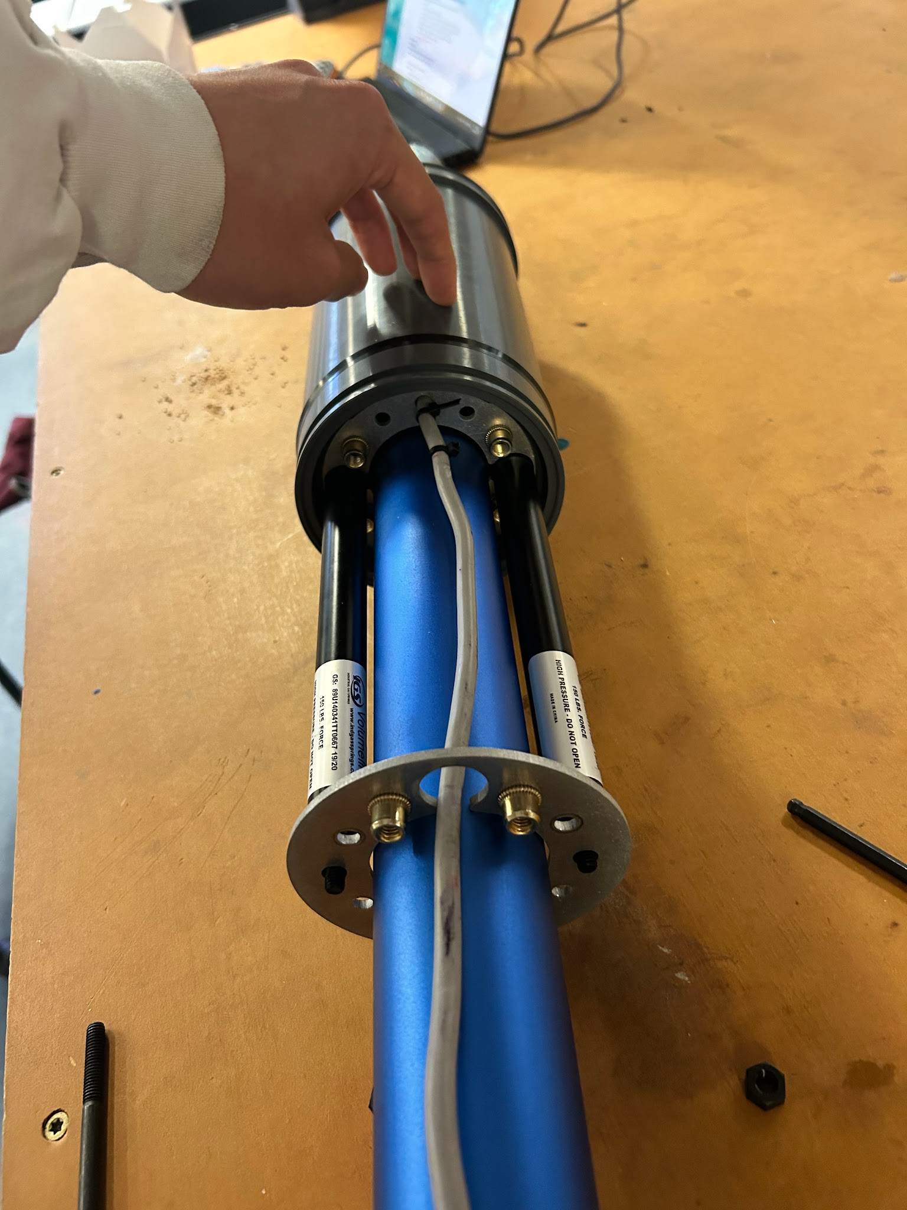
- CRITICAL: Verify that the free ends of the two #6 gas springs are properly aligned with the two counterbored slots in component #5 before proceeding. As shown in Fig X.

Fig x. Pistons aligned inside of counterbored holes.
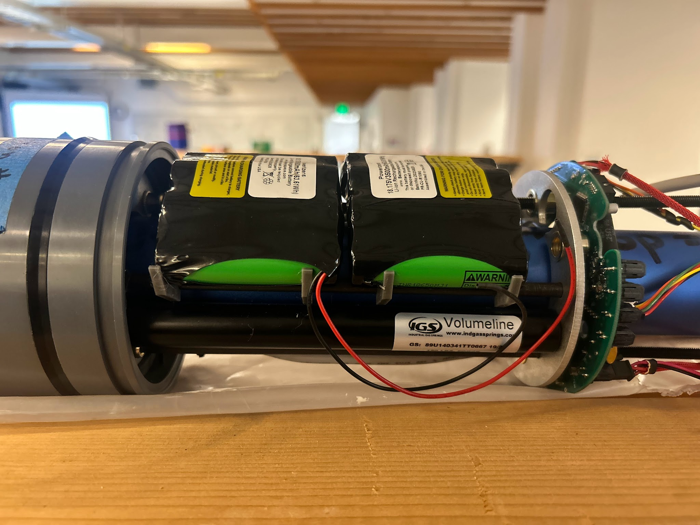
- Battery Carriage Installation: Attach the 4 battery packs to the 3D printed battery holders(#X) shown in Fig X.

Fig X. Batteries mounted on 3D printed parts.

- Critical

Outer Assembly

Outer Assembly:

1. Extend the actuator all the way out.
2. Generously coat inside of housing #1 up ~10" from non cross drilled end, and Internal Assembly Piston1 OD, including piston seal, with Aqua Shield grease.
3. Install Piston1 Installation Tool Assembly, 500152, around housing #1.
4. Install wear ring #43 into piston #4, hold in place with your fingers.
5. Insert Inner Assembly half way into housing #1, in the side opposite the end cap cross drilled retaining holes.
6. Remove Piston1 Installation Tool Assembly, 500152.
7. Fully insert Inner Assembly into housing #1.
8. Lightly coat #36 with Vibratight threadlocker and wait 15+min.
9. Screw Endcap Assembly #2 onto #36 until it bottoms out.
10. Rotate housing #1 until endcap retaining holes line up with the cross tapped holes in the endcap (May need to use a strap wrench).
11. Coat #2 sealing O-ring and the first ~1" of the ID of Housing #1 with Dow Corning Silicone #4 grease.
12. Command the actuator to retract ~9". As the actuator retracts, guide the endcap#2 into housing #1.
13. 2X: Put a drop of Loctite Threadlocker 425 onto #31. Install Endcap retaining screws, #31 w/ #4 until #41 is fully compressed. Be careful not to overtighten.
14. Slide first #21, as shown over Piston2.
15. Lay #29 into the groove in #21, hold in place while you install 2nd #21 over the end of Piston2.
16. Secure in place with #20.
17. Fully retract actuator.
18. Run diagnostics tests and put instrument into storage mode.

Sensor Cap Assembly

Sensor Endcap Installation Instructions:
- #10 and #54 insertion into Endcap
- If not already installed, insert #54 into #10
- Smear a light layer of Molykote(O-ring grease) into the O-ring indent of #10(the larger gap)
- Insert O-ring #38 into the greased gap, and insert into endcap hole #5, push #10 so that it is flush with the top of the endcap
- Insert metal retaining ring on #10 on the inner side of the endcap,(example in photos below.

- #8 Endcap Installation
- Smear a light layer of Molykote(O-ring grease) in the larger indent of #8
- Insert O-ring #38 into the greased gap, and insert into endcap hole #4, push #8 so that it is flush with the top of the endcap
- Insert metal retaining ring on #8 on the inner side of the endcap,(Figure 1&2)

- #11 Endcap installation
- Smear a light layer of Molykote(O-ring grease) in the larger indent of #11
- Insert O-ring #38 into the greased gap, and insert into endcap hole #2, push #11 so that it is flush with the top of the endcap(it may not be completely flush.
- Insert metal retaining ring on #11 on the inner side of the endcap(Figure 1.)
- Insert power wires and communications wires into #28
- Insert #28 into #11, the top of #28 should sit below the threaded inner lining of #11 shown in Figure 3.
- To Seal, screw in the bolt shown in Figure 4.

- #30 Antenna housing endcap installation
- Wrap #32 in foam and tape to keep in place
- Insert #32 into #30, with the foam attached.
- Insert into hole #1 of endcap and push flush with the top of the endcap
- Secure with #33 retaining ring

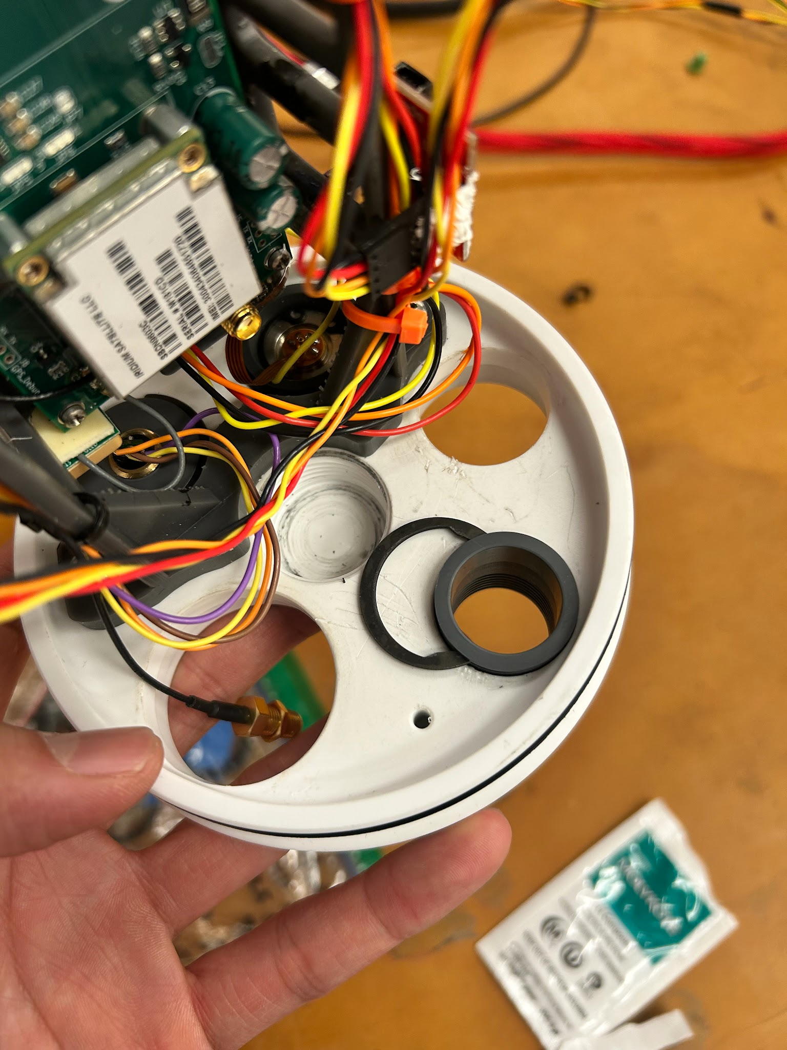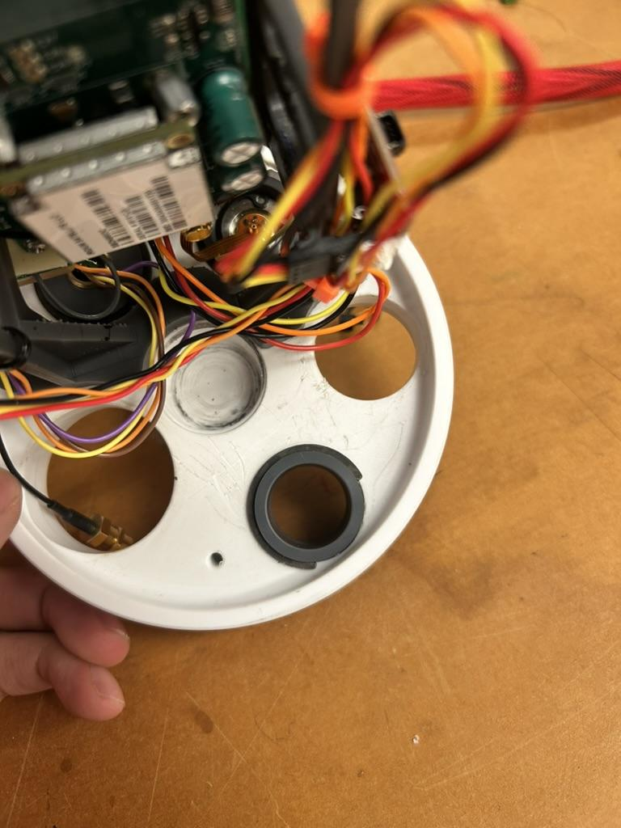
Figure 1 and 2. Retaining ring installation

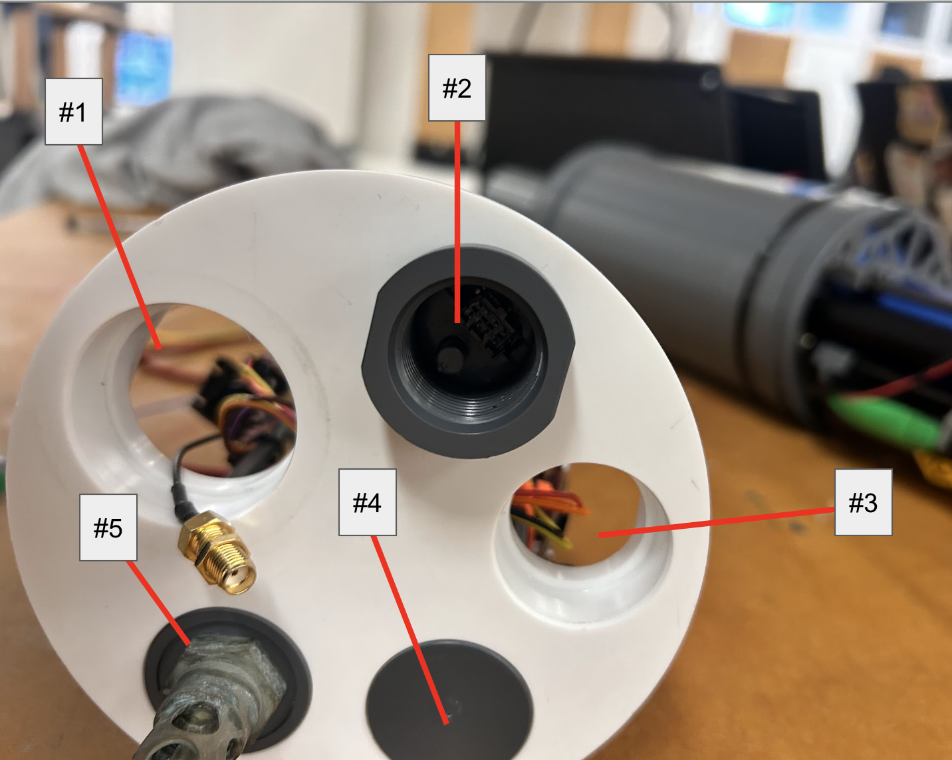
Figure 3. Endcap hole labels.

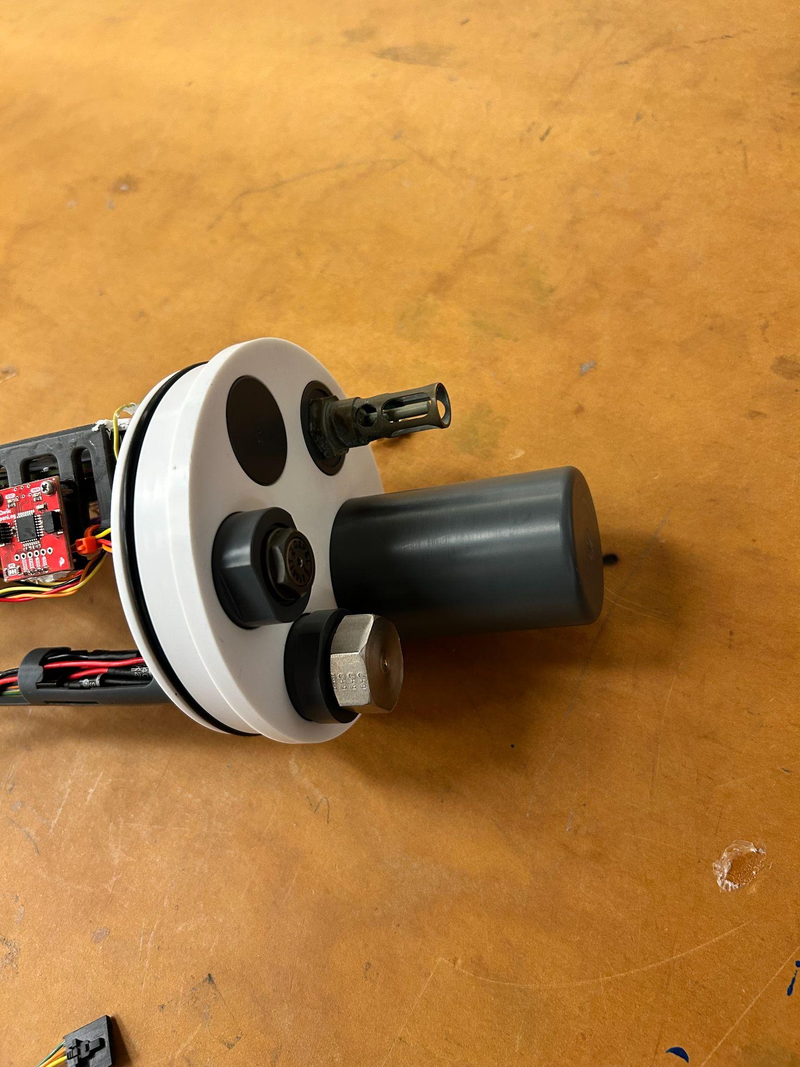
Figure 4. Metal screw cap for power and comms
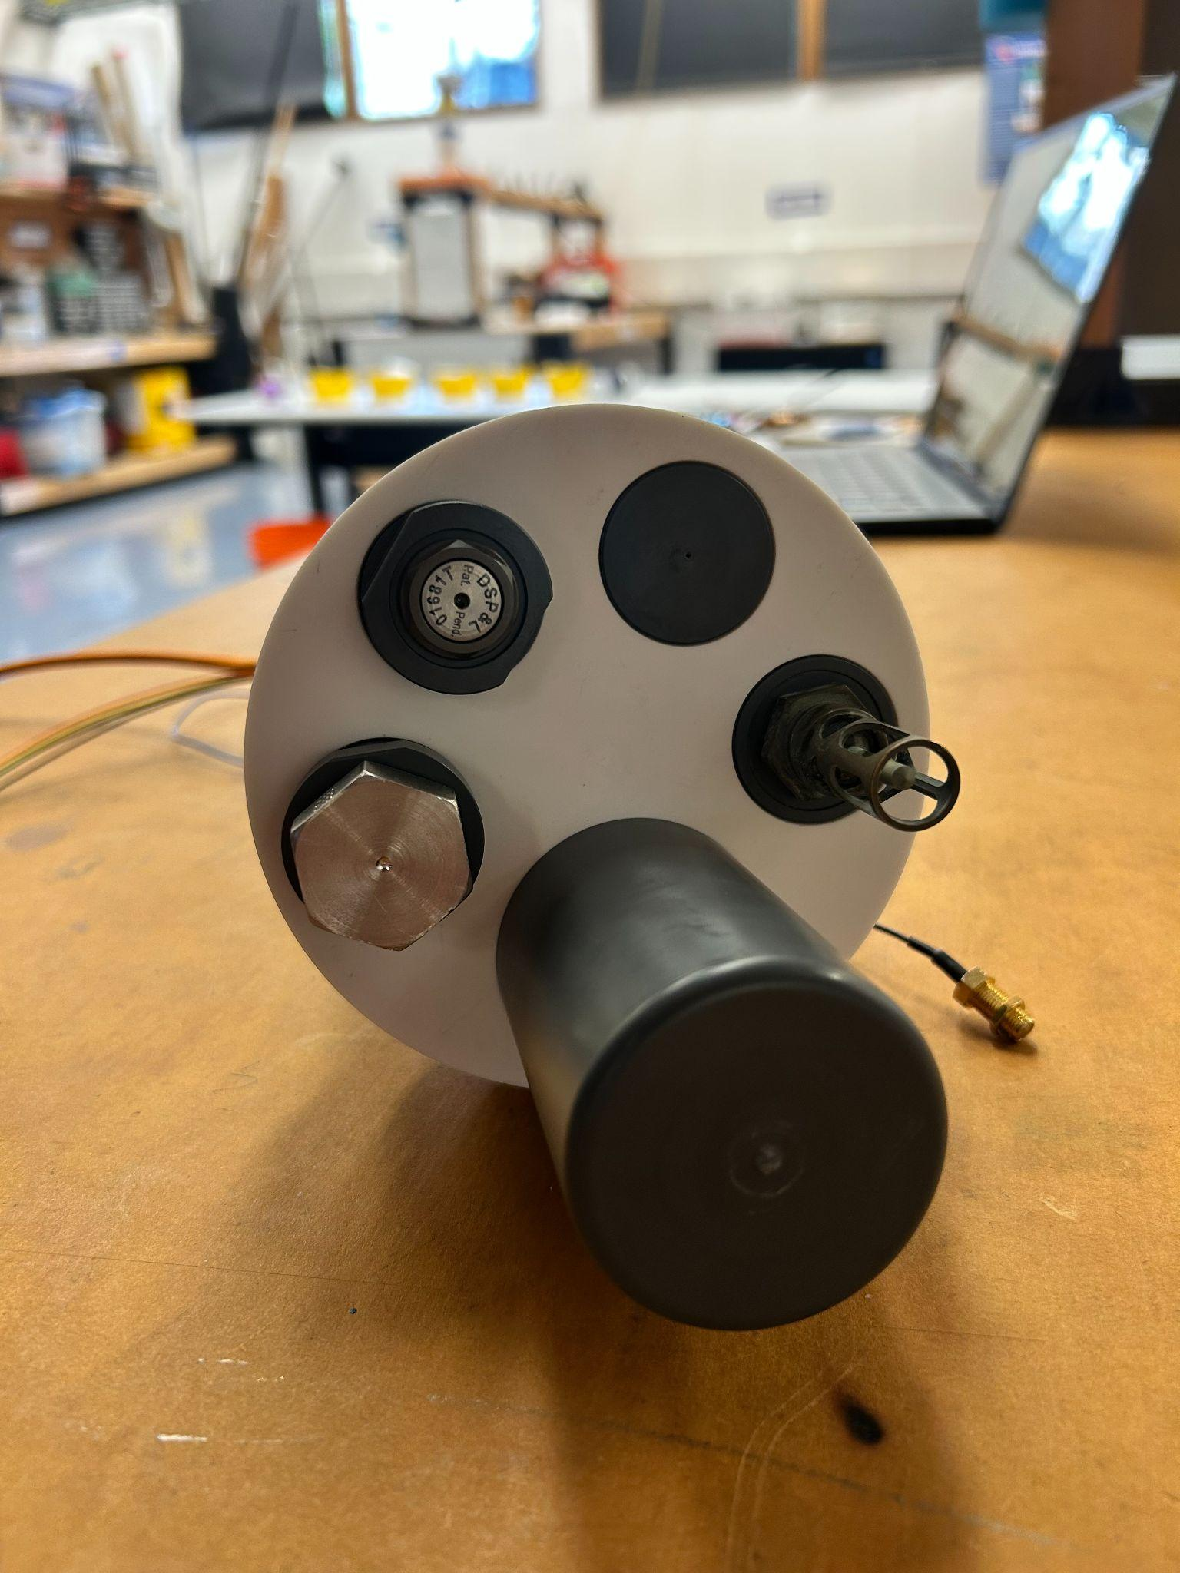
Figure 5. The completed endcap.

Flashing the Control Board

Flashing the Control Board

Please follow the instructions in the LCP quick start document under firmware flash. You use the segger j-link flashing tool to flash the new firmware onto the LCP control board, after you make the configuration and artemis debug.h file changes and save them. You can then use the TTL to usb board and teraterm to monitor the output of the control board, but you cannot send commands to the control board. Everytime you re-apply power the LCP will restart per the settings in the configuration file, and will then profile until it either runs out of power, or you reach the number of profiles set in the config.h file.

Note: After flashing with the J-link remove the J-link cable and power off the LCP. Then resupply power and hit the reset button/switch, this will start the LCP with the correct profile.

https://github.com/NOAA-PMEL/EDD-LCP_Control/blob/Ver1.0/LCP%20Quick%20Start%20Guide_v0.pdf

Git Hub Links
Git Hub Links

- NOAA-PMEL/NOAA-PMEL-Low-Cost-Profiler: NOAA PMEL's Low Cost Profiler Opensource hardware and Software Repository

